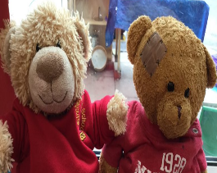

**Try this at home!!**

Learn a joke to share with your friends on Red Nose Day.

The daffodils are growing on daffodil hill at school. When you are out and about see if you can spot any daffodils. What colour are the flowers? What colour are the leaves? What shape are the petals? How many petals can you count? Do all daffodils look exactly the same? Can you could paint or draw some daffodils?

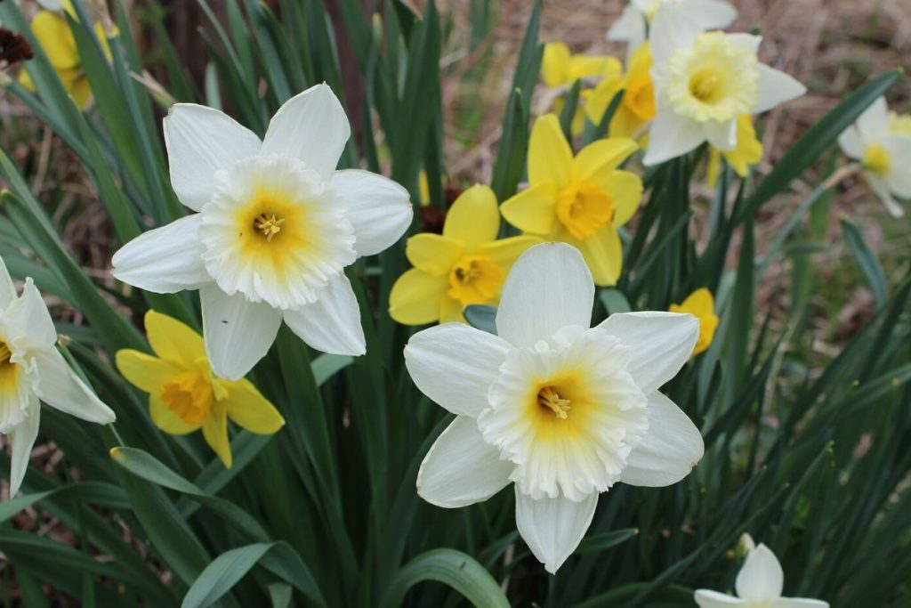

**Story of the Week**

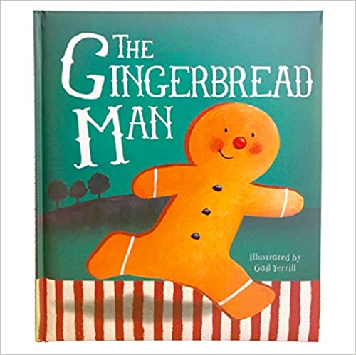

This week we have shared the story of The Gingerbread Man.

If you have a copy of this story at home please share it with your child. There are lots of versions online that you could also look at.

Please encourage your child to join in with the repeated refrains, “Run, run as fast as you can, you can’t catch me I’m the Gingerbread Man”.

Feeling happy about something I have done or about something that belongs to me.

“I am proud of my painting”

**WOW stars!**

You will find WOW stars in your child’s Home Learning Wallet. Please use these to record any achievements from home eg fastening coat independently, riding bike, helping with jobs etc. We will then share their WOW moments in class and display the stars on the special WOW Star board.

**Notices-**

Home Learning Wallet please return on MONDAY.

You may include: certificates, WOW stars, messages or any weekend news for us to share in your Home Learning Wallets.

**Dismissal**

11:30 - Middle gates off car park

12:15 - Middle gates off car park

3pm- Nursery class gates.

**Welcome back and well done!**

We have had a lovely week, all together, back in Nursery. The children have been amazing! They have soon settled back into the routines of Nursery life and have enjoyed exploring their learning both indoors and outdoors. It has been great to welcome some new children into Nursery, they are already part of our Early Years family, making friends and getting involved in all that is going on.

**Save the Date**

* 19th – Comic Relief – wear red or any Comic Relief items you have

Birches First School

Nursery Newsletter

Spring 2 Week 3 – 8.3.21